Invitational Report - Zvi Mowshowitz
Zvi Mowshowitz
Star City is an Evil place. Not just an evil place, an Evil place. We're not talking trick Nicolai Herzog into playing a deck that only beats Chris Pikula evil, or you didn't block with Wall of Blossoms evil. We're talking Jason Gordon, "if I were to have a Healing Salve in my hand" level Evil. The place is downright sinister. I walked into the Star City Hotel, and there were giant posters all about. Some had some very determined but ecstatic people on them, holding Australian dollars. And others had a yellow cartoon animal in the shape of a fleshed out star with a huge fat grin on its face. They all had the same motto, offering the promise of... prepare Dr. Evil accent and finger...
ONE... MILLION... DOLLARS!

Of course, those are Australian dollars, which are like the new horribly disfigured American dollars, but then color coded and with a hole in them, which makes them worth about half as much. Then there's the taxes. But it's still not chump change. What these posters were advertising was a special offering of the hotel's casino. They strap a helpless lucky citizen who was mathematically ignorant enough to be using the electronic slot machines into the kind of suit that's normally reserved for workers at leaking nuclear power plants, and shove them into a see-through tube with cash on the floor. Their job is to grab as much cash as possible before time runs out. This is the reward they get for spending time literally giving the casino money playing the slot machines. Back in the day, slot machines actually did something. A victim (I mean player) would put money in, and pull on a lever. Actual rolls of symbols would spin, and when they lined up in the right combinations, they would occasionally give back large numbers of quarters. But the modern five star casino has decided that's too slow, gives the players too much exercise (giving them enough energy to do something of redeeming social value) and is way, way too much fun. So instead, now slot machines deal with electronic roles of symbols, don't require the victim to do anything between spins, and keep track of winnings and losses on screen. In other words, it's now about as much fun as playing against a Bargain deck: Sit there while the machine does stuff and ask who won. Which apparently some people enjoy.
Anyway, I got to witness this miracle of modern economic opportunity in action. Me, Bob Maher and I think one of the Deadguys were walking across the casino. This would be a good time to point out why we were walking across the casino. Not that I remember what we were going to or from at the time, because I don't. But that's the way to get from Point A to Point B, especially the downstairs Point Breakfast, at this hotel. The fastest way is through the casino. There are alternate routes, for people under eighteen or carrying bags or wearing the wrong kind of pants, but practically speaking it's easier just to go through the casino several times a day. I'd actually never been in a casino before, but I've been assured that this is standard procedure for obvious reasons. So this old lady steps into the cylinder of cash. The excitement builds, the crowd gathers and she's off! She starts kicking the money off of the floor, it starts spinning around in the wind and she starts grabbing at it.
Why didn't she just kneel down and pick up the money or slam it against the sides? Because she wasn't allowed to. Not content to torture an innocent soul that couldn't do mathematics, they also had to make sure The Fix was in. So they took this format and they banned the cards that gave the player a chance to make money. You can't take the cards from the bottom. You can't use the wall. You can't use anything but your hands to keep the money. So what happens is this good citizen starts kicking and grabbing for bills and coming up empty. Near the end, she grabs hold of a single bill. Turns out that she broke the format: in her hand was the most valuable single bill available. A fifty. The house wins again.
At some point I should mention my preparations. Good, that's over with. Well, that's not quite true. I did put thought into my card, and I went to Neutral Ground and worked out a sponsorship deal in exchange for them loaning me the cards for my decks. Brian David-Marshall dug into his own collection to find me Alpha versions of the power cards, which was really cool, and I got polo shirts to wear during the competition. As for the card, I had a bunch of ideas, but nothing definite until I started thinking about Yawgmoth's Agenda. Yawgmoth was at it again, but this time he didn't allow more than one spell a turn. That still allowed spells on the opponent's turn and one good spell every cycle still isn't such a bad deal, but together with putting a Planar Void on the controller for life, the Agenda kept missing out on decks for incidental reasons. I loved the idea of permanently letting a player play spells out of the graveyard, but it was clearly broken at any reasonable cost without some onerous restriction. Then it hit me.
There's a second graveyard. The opponent's. Why not just use that one?
This solved a ton of problems. First, it put an additional requirement on the card, since the opponent's spells might be the wrong colors. Five color lands could handle this, but without them I was worried the card would be relegated to the sideboard. Then I remembered lands can be played out of the graveyard too. Their lands cast their own spells, and they seal their own doom!
The End.
The Very Very Very End!

Just kidding. Anyway, back to the card. It was obviously incredibly powerful, allowing its caster to access a whole graveyard's worth of additional spells. It also wrecks the opponent's graveyard. I tried to limit that by making the removal from the game upon hitting the graveyard the opponent's option, but once the card gets going that option's going to get invoked almost all the time. For costing, the other similar graveyard recursion cards all cost 3BB, and this one seemed more powerful (more gain) but also less reliable and in many ways less abusable. Since there's no way to control what cards are in the opponent's deck, his graveyard probably won't grant any infinite combinations or such. In all, anything less than five mana seemed like it was too cheap, but at five mana other similar cards had been fine. It was clearly black, so it costs 3BB. Reaction has been positive to the card. Many people see it as a 'little kid card,' fun but not all that good at the tournament level. Others see it as what I suspect it is, a monster sleeper if it were ever to get made, although not actually broken. Either way, I was very happy with it.
Two days before the election, I was checking my secondary E-mail address with a program called Cunix, and I used the command 'fortune.' I forget the exact reply, but it was something like: "A new strange development will occur every time you ask 'What Next?'" I've been asking it ever since. You get what you pay for, I guess. Now, on to the five disasters. Their names were Duplicate Limited, BYOB, Solomon Draft, Auction of Champions and Type I.
Duplicate Limited had a change this year: The sideboard could only contain two basic lands. That meant that players were locked into whatever colors they chose during deck construction. The cards were all recosted versions of existing cards, most more expensive than before. I sat with Bob Maher for deck construction. The card that struck me was The Abyss sitting there at 1BB, with lots of neat combinations arising from it. Whenever I looked at another kind of deck, I kept thinking 'I'll lose to The Abyss, I'll lose to The Abyss.' Bob was having a similar experience with other cards. He kept finding crazy combinations and predicting 'I'm going to lose to this.' Mark kept telling him to play whatever he was complaining about, and Bob just replied it wouldn't come up for him. I know exactly where he's coming from. Playing at the higher levels requires playing consistent cards and consistent decks, and when something that isn't consistent enough to play ends up beating a Pro down because it came up at the right time it can be infuriating. I don't hate losing that much, even losing to bad players is all right, but losing to bad CARDS is very bad times.
Anyway, I look at all the cards and my impression was that the control cards, while slow and expensive, are going to have enough time to beat the aggressive cards. I didn't see the beatdown decks coming together at all. So if the important question was control, the deck needs to be built to win control wars. That meant taking white for Devout Witness (looked like the best card in the format at 3W), blue for Forbid and Mana Drain at 2UU and 3UU respectively, especially Mana Drain with cards like Nevinyral's Disk and Triskelion at 8, and black for The Abyss and Demonic Tutor, with the Tutor at 3BB. I took every way to force out The Abyss, and what I thought would be enough ways to make it win for me, along with as many neat combos as possible. And game one of round one I had Dave Price in a Forbid lock with Argivian Archeologist, until I had to find a way to win and had to use Taniwha, forcing me to realize that maybe my deck wasn't so hot in ways other than the twenty land I had to use, not counting the three casting cost Black Lotus. He too built a poor deck, but apparently hit upon the right lands to use. I lost one game to a poor draw, and one game to third turn Wild Mammoth (1G) and Revered Unicorn (W) beatdown. I liked those, but didn't see a way to back them up. Sigh. Round two I got smashed again, this time by Yoshikazu and the amazing Goblin Bombardment (2R) and Living Plane (1GG) combo. I was going to get out because of the twenty lands but then there was a Groundskeeper. Oops. Round three I played against Ryan Fuller, and managed to tune my deck all the way to halfway decent after sideboarding. The Abyss wasn't anywhere near as good or important as I suspected, but it did at least win me one match.
Next up was BYOB, or Bring Your Own Block. Me and Seth Burn spent about a day on this format, but Awakening was handling the aggressive decks. After all the creative deckbuilding that came out of last year (if Trix aren't for kids, they're at LEAST for real tournaments, you spoil sports, and the same with Yawgmoth's Bargain) I decided to just play Awakening again. It's really solid, how bad could it be? I worried about it being unoriginal, since I may have built it back in the day but I used it last year, but when I found I was the only one playing the deck I didn't mind. I thought about changing one of the blocks but all three seemed vital. So I played the same maindeck I played last year, with Wasteland added to the sideboard to help against manlands, Kjeldoran Outpost and Stalking Stones. I added two, should have added four but I would have been metagaming against players whose decks I knew and I didn't want to win enough to do that.
In the three matches, I faced Tradewind-Hermit-Opposition from Kai, and unlike last year I never was in a position to block so I won. Actually, it wasn't that simple, and Kai's deck was better than the pure Squirrel Prison deck available last year, but the basic idea was the same: Oath of Druids is dangerous but worth it for me, with both sides able to spring a Tradewind Rider trap but me having a better shot at it. I squeaked the series out, with him drawing duplicates one game when he had me locked down for a few turns. Next up was Mike Long, playing Ponza. I lost game one in convincing fashion, and game two I drew three Islands in the first half of my deck after using Oath of Druids to stall the game. As soon as he found enough burn to close the gap in life totals, his Fireslingers made me history. Land destruction isn't good for the deck, even with the two Wastelands in the sideboard. Last round of the format was Jon Finkel with Draw-Go, which was an odd choice with a ton of red out there but Finkel can do whatever he wants. This is about as bad as this deck's matchups can get: he had twelve counters, Masticore for the late game, Legacy's Allures to match mine plus Kegs too, and a full Capsize and Whispers set to match mine as well. Game one I had to go for Awakening or die a slow death, and he had the perfect hand. Game two was long but his deck had more cards that count than mine so unless he messed up it was only a matter of time after a while. He didn't. Come on, this is Finkel we're talking about.
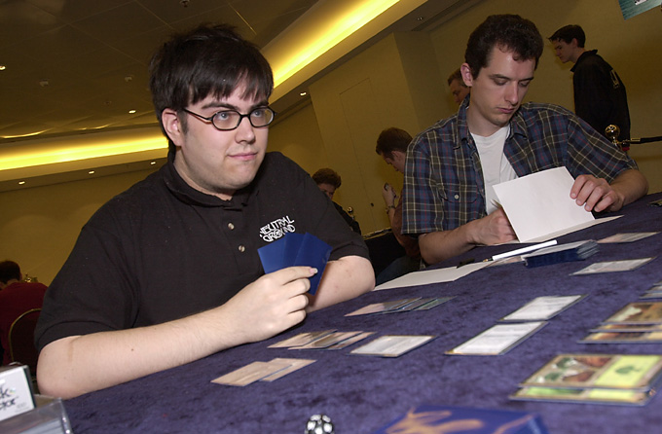
Then came Solomon Draft. I'm horrible at Solomon Draft. Not Chris Pikula bad, but I'm very bad. I just can't remember enough about the previous cards, or do good divisions fast enough. There's just too much for me to process. My first match was against Gary Wise, and it was all gold cards aside from dual lands and Cameos. I couldn't have played it much worse, completely oblivious to the fact that he had a three color draft deck and I had a five color special. It wasn't pretty. I get a great draw, four of my colors of mana, and he puts out Shaku's Minion against my two white/blue 2/2 flyers. It was that kind of tournament. Did I remember he had a Minion in his deck? You're kidding, right? Gary was the only player in the room with a three color deck. Everyone else had four or five. Well, after getting totally crushed by Gary Wise it can't get any worse, can it?
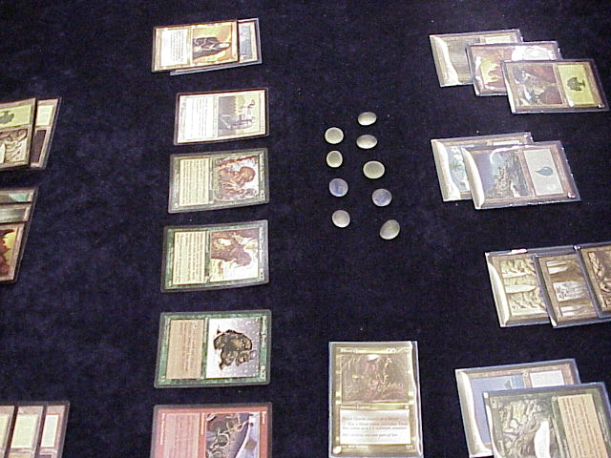
It almost did right away. Instead, it had to wait a few rounds to actually get worse. Next round I faced Gerardo, who I'd played at Worlds this year on Day Three. He was up one game and had Aura Fracture, Story Circle (naming blue) and Predator, Flagship all out against a Rising Waters deck with seven mana available and I came back to win with a Bribery. Finally, everything seemed to go right. I'd be happy with his divisions. I'd divide more or less evenly a lot of the time, and when I didn't he'd go for the wrong pile. This draft was all about Legends, and he made the kind of mistake I made all day: he didn't realize how important Legend control was. I got the Sisay cheap, the Sword of the Chosen cheap, Empress Galiana cheap, et cetra. I also got the multi-colored mana cheap. In the end, I decided I was out of the running and played all five colors to get a Sliver Queen since I had Harrow, Fertile Ground and Sol Grail. It's the Invitational. Game one I stall at two lands for a turn with the Sol Grail but he's not active so I have time. I get Sisay out and start thinning my deck to find land, cursing myself for not using the Keldon Necropolis and having drawn the Kor Haven. I get Asmira, Holy Avenger out first and play her, then go for the Sword and then Karn but can't find the fifth mana. An Agonizing Demise makes Asmira bigger, and together with the Sword, I've got some serious beatdown. But out pops Multani, Maro-Sorcerer, and I suddenly realize I totally underestimated that card here. We're both mana screwed, and he's something like 14/14. I take it once and then chump with Sisay, her mission complete. I draw the Harrow. Where were you ages ago? I don't have the mana to use Harrow and play a blocker, so I'd have to chump with Asmira which would virtually end the game. The other option was to attack into a blocker. If he takes it I use the Sword and he goes to one, I Harrow and he dies to Breath of Darigaaz, my only non-gold red card. If he blocks that's game, since I can't play a chump. I keep my poker face, he takes it and I win the game. Game two the Multani comes out and demolishes me while I ask where my mana is. Game three I start out with Sliver Queen and only Forests and Islands. We start playing lands. I draw the one Swamp. Interesting, but I'm still flooded. Then I draw the one Mountain. Four turns, four colors of mana. Come on, Plains! I draw the Kor Haven. Figures. Then I get Fertile Ground! I play it, and out pops the Sliver Queen. Many tokens later, I swarm him for the kill the turn after he finally gets the second white mana to cast Mageta the Lion.
Last round of Solomon was against Ben Rubin. This time it was all about color changing and protection from colors. I felt the draft actually went all right, but his deck turned out to be one tight little package. I had a good one too though. Game one I drew five Forests and only one each of Plains and Island, and not having double of either one cost me the game. Game two I just got slaughtered. Oh well, 1-2 was actually better than I expected there.

But there's this little secret about Long's deck: it doesn't work!
Day three was the Auction of Champions and Type I. The Auction was a ton of fun, and playing was cool too. I felt that players were in general underpaying for decks. Early on, Mike Long's Prosper-Bloom deck came up, and I was hoping to get it. There was a bid of six cards, twenty life, I think from Darwin Kastle, and I hadn't played him yet. I felt that was a bid I didn't want to play against, so I bid 6/19 to force the price down - if 6/20 is worth it then 6/18 would be too, I'd think. But everyone sat down, and I was stuck with the deck. Oh well, I wasn't too upset. But there's this little secret: the lousy deck doesn't work! Round one I played against Pikula, who hadn't realized that The Fix was in on Maher's deck and had bid against Finkel for it, getting it at six cards and double digit life. I don't win that matchup. Then came Bob Maher, playing Loconto's old W/U Millstone deck at 7/20. We both thought I should just blow by him, but little did we know he had the right stuff.
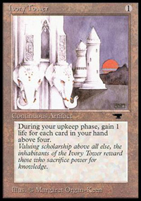
Game one he puts out Ivory Tower, and I don't quite have what it takes to go win. He goes up to 30, which is already pushing the envelope for this deck, and I use a Memory Lapse to get off a Natural Balance. But I'm just short of being able to win that turn. So he gets to untap, gains one more life and says done. Next turn I go off with counter backup, take every risk I can, draw my entire deck, and use every card in my hand and every card in my library and every card but Squandered Resources and Cadaverous Bloom in play to Drain Life him for... 31. He activates a Mishra's Factory and Plows it. I had no other play, but I felt like Brian Davis. Game two he gets down Zuran Orb so I can't Natural Balance or he goes all the way to 40, and he Strip Mines (he has one) my only Forest. After a few turns I have everything I need but the green, with three City of Solitude (which would let me Balance again too) and the whole combo. But no green. I get it down and play Squandered Resources. He stops that, and uses the one Recall to get back the one Strip Mine. Meanwhile, two Millstones are putting a huge damper on plans. I have the Drain Life (and kept in the Elven Cache) so it's not going to be fatal, but I'm running out of room rapidly. Finally, I have to go for it prematurely because of the Millstones (since I don't have the green to play out the Cities) and he stops me without too much trouble.
Then I play Alex, who has McCarrel's deck. Finally, someone I can crush. Game one I win on turn four. Game two I Prosperity for nine with a tapped Island, Squandered Resources and Cadaverous Bloom in play and a blue in my pool, having used a Natural Balance and with the whole combo except Elven Cache still in the deck. So I win, right? Nope! The deck fizzles on me. I Impulse, still no luck. He lets me back into the game and I go off, but I run out of cards and can only Drain him for 14. Game three I don't get the engine (or even just Squandered Resources) and he Helix locks me. I almost get out but he topdecks the mana he needs to use the Key to get around two Bad Rivers.
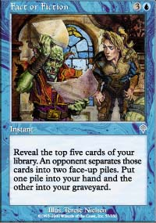
Then comes Type I. I brought monoblue since I went 3-0 with it last year, and Type I gets lame quickly if the players care a lot so I didn't work on it much. I decided to get around The Abyss and Swords to Plowshares (since I figured most would go 5 color blue) by turning Ophidian into Fact or Fiction, tuned the deck a little and played it. First up was Trevor Blackwell, and he was playing a deck I knew I beat from playtesting earlier in the week. But I can't find land early on, so I have to take a little damage before Morphling stabilized the game, and then I got too many lands later on. Holding Misdirection and Force of Will, I can't find a blue card so when he uses Kaervek's Torch on me backed by Pyroblast that's game. I win game two but I get another bad draw game three and I lose the match.
Next up is Darwin Kastle. His deck draws pretty poorly, and doesn't put me under much pressure. With time to work, I get to use Fact or Fiction, and that helps me win the waiting game. We both sideboard wrong for game two, with him taking Lightning Bolt over Incinerate (problem is Masticore in my sideboard) and I didn't keep all four Fact or Fiction in the deck, thinking his deck was faster than it was. I find my mistake as does he, but in two long games Fact or Fiction pulls it out. In the final match, I played against a multicolor version of my deck played by Noah Boeken. I forgot he had the Strip Mine in game one and got a little too aggressive, and it turned into a topdecking war he won. Game two also came down to a topdecking war after he got a better draw but not enough to turn into a win, and he won that one too.

So I'm last. That's ok. It was worrying me until it hit me that it didn't actually matter. I came, I played, I had fun except when I was thinking about how badly I was doing. Someone's gotta be last. And the last two have won Pro Tours.
What Next?

